EXPERIMENT 17
Determination and plotting of Antenna Gain Calculation.
Aim:
To determine and plot Antenna Gain, and calculate the antenna gain in dBi
Software required:
• SCILAB version 6.0.1
Program:

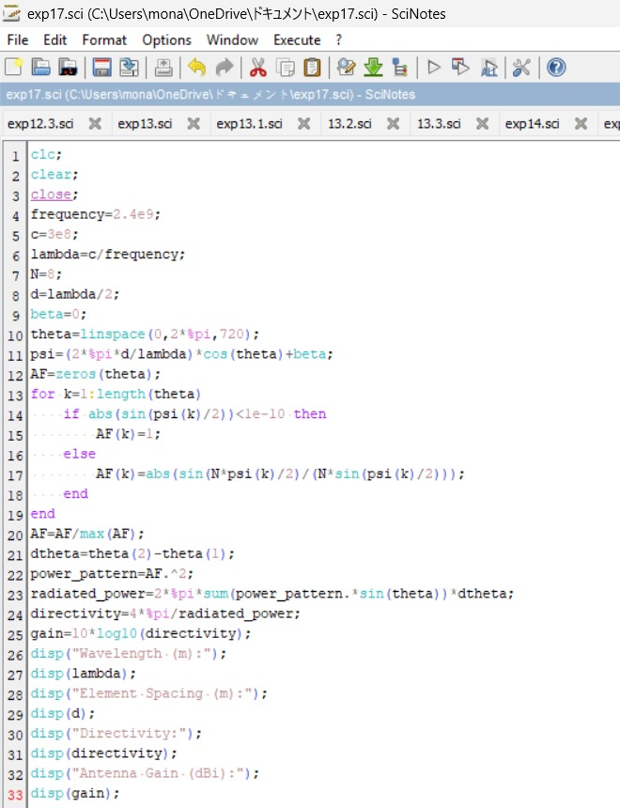

Output:
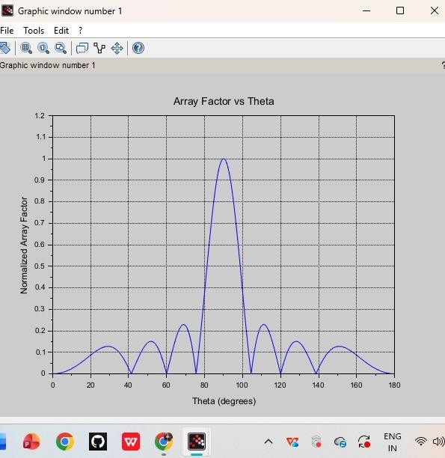
RESULT: The experiment was done and the gain calculation for the given antenna was done. Different case studies were analyzed and the gain was calculated.

